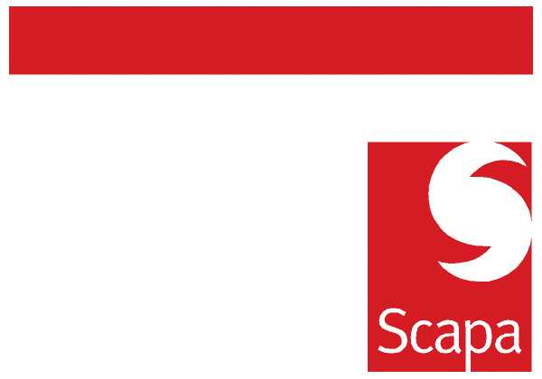

26 February 2010

SCAPA GROUP PLC

ANNOUNCEMENT

I am pleased to announce that Maggie Stubbs will be joining Scapa on 1 March 2010 as Group HR Manager.

Maggie will be responsible for all generalist HR activities at the UK sites, including the Head Office functions. Her focus will be to work with the management teams to identify and develop effective HR policies and solutions that support business objectives.

Maggie has extensive experience in generalist HR operational roles gained within a variety of industries including manufacturing, retail and distribution. The majority of Maggie’s experience has been gained in Asda and Grattan plc, where she was HR Manager.

Maggie will be based at Ashton and report directly to me.

Julie Hulme
Group HR Director

